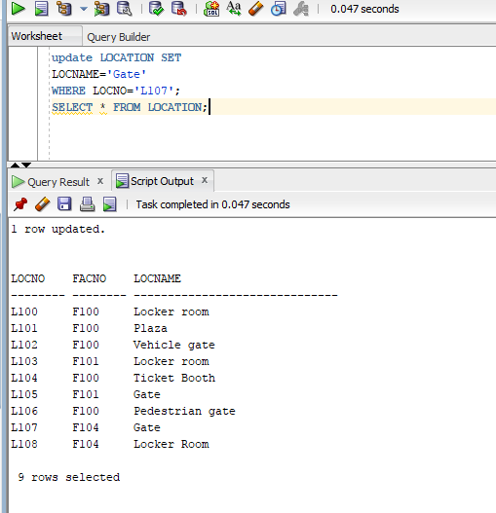
Update LOCATION SET LOCNAME=’Gate’ WHERE LOCNO=’L107’;
SELECT * FROM LOCATIONS;

